COMSOL, Inc.  100 District Avenue  Burlington, MA 01803 USA  Phone: +1 781-273-3322  Web: www.comsol.com  Blog: www.comsol.com/blogs | Media Contact:  Natalia Switala, PR & Communications Manager  natalia@comsol.com  COMSOL Conference 2018 Call for Papers:  www.comsol.com/conference/call-for-papers

COMSOL Announces Deadline to Submit Presentation Abstracts for the COMSOL Conference 2018

Users of simulation and analysis software are invited to submit abstracts by July 20, 2018 for an opportunity to present their work at the COMSOL Conference 2018.

BURLINGTON, MA (March 28, 2018) — COMSOL has announced that the Program Committee of the COMSOL Conference 2018 has started to accept abstract submissions for posters and papers. Presenters will have the opportunity to showcase their modeling and simulation work to colleagues within industry and academia and get recognized for their contributions to the simulation community. The conference fosters an environment that opens a dialogue for advancing skills and further innovation in multiphysics modeling.
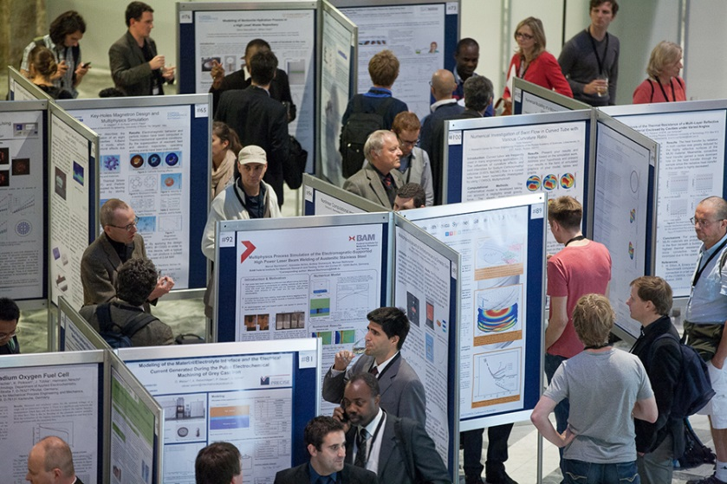
The papers and posters accepted for presentation will reach approximately 2,000 conference attendees across the globe. Additionally, the Conference proceedings are then published online for public access, amplifying the reach beyond those directly in attendance.

"The COMSOL Conference provides the best opportunity to talk with other users about their experiences and challenges. Such cross-fertilization provides great opportunities for professional growth." said Kyle Koppenhoefer, AltaSim Technologies, a COMSOL certified consultant.

The COMSOL Conference 2018 Boston will be held October 3-5, 2018 at the Boston Marriott® Newton hotel. For a list of worldwide events and deadlines visit: www.comsol.com/conference.

Suggested topic areas for papers and posters include, but are not limited to:
- AC/DC Electromagnetics  - Acoustics and Vibrations  - Batteries, Fuel Cells, and Electrochemical Processes  - Bioscience and Bioengineering  - Chemical Reaction Engineering  - Computational Fluid Dynamics  - Electromagnetic Heating  - Geophysics and Geomechanics  - Heat Transfer and Phase Change  - MEMS and Nanotechnology | - Microfluidics  - Multiphysics  - Optics, Photonics, and Semiconductors  - Optimization and Inverse Methods  - Particle Tracing  - Piezoelectric Devices  - Plasma Physics  - RF and Microwave Engineering  - Simulation Methods and Teaching  - Structural Mechanics and Thermal Stresses  - Transport Phenomena
“Presenting a poster, paper, or both at the COMSOL Conference is a great opportunity to gain exposure, establish your credibility within the simulation community, and connect with specialists in your field” says Sarah Fields, Program Chair for the Boston conference.
Each location has a program committee of simulation specialists from industry and academia who review the abstract submissions and assist in selecting the best paper and poster winners at the Conference.
Presentation guidelines for oral and poster presentations, and more details about the COMSOL Conference 2018, visit: www.comsol.com/conference/call-for-papers.

About COMSOL
COMSOL is a global provider of simulation software for product design and research to technical enterprises, research labs, and universities. Its COMSOL Multiphysics® product is an integrated software environment for creating physics-based models and simulation apps. A particular strength is its ability to account for coupled or multiphysics phenomena. Add-on products expand the simulation platform for electromagnetics, structural, acoustics, fluid flow, heat transfer, and chemical applications. Interfacing tools enable the integration of COMSOL Multiphysics® simulations with all major technical computing and CAD tools on the CAE market. Simulation experts rely on the COMSOL Server™ product to deploy apps to their design teams, manufacturing departments, test laboratories, and customers throughout the world. Founded in 1986, COMSOL employs more than 450 people in 19 offices worldwide and extends its reach with a network of distributors.
~
COMSOL, COMSOL Multiphysics, LiveLink, and COMSOL Server are either registered trademarks or trademarks of COMSOL AB. Marriott is a registered trademark of Marriott International, Inc. For other trademark ownership, see www.comsol.com/trademarks.

